

**PROJECT GROUP MEMBERS**

|  |  |
| --- | --- |
| ***Students Id*** | ***Students Name*** |
| ***Student1391568*** | ***Syed Muhammad Arham*** |
| ***Student1421636*** | ***Muhammad Anas*** |
| ***Student1425430*** | ***Muhammad Talha*** |
| ***Student1449759*** | ***Muhammad Hassan*** |
| ***Student1413553*** | ***Murtaza Mustafa*** |

**CURRICULUM**

**7062**

**BATCH**

**2301C2**

**SEMESTER**

**3RD**

**CO-ORDINATOR**

**MISS MAHA HAIDER**

**FACULTY**

**SIR HARIS NASEER**

**Certificate**

This is to certify that the dissertation **“Symphony Limited”** is **Syed Muhammad Arham Student 1391568, Muhammad Talha Student 1425430, Muhammad Anas Student 1421636 Muhammad Hassan Student 1449759 Murtaza Mustafa Student 1413553** in their partial fulfilment of the requirement of the award of the Aptech Computer Certified.

**Acknowledgement**

The success and final outcome of this project required a lot of guidance and assistance from many people and I am extremely privileged to have got this all along the completion of my project. All that I have done is only due to such supervision and assistance and I would not forget to thank them.

I respect and thank Aptech for providing me an opportunity to do the project work in ACE and giving us all support and guidance, which made me complete the project duly. I am extremely thankful to Aptech for providing such a nice support and guidance.

I owe my deep gratitude to our project guide **SIR HARIS NASEER**, who took keen interest on our project work and guided us all along, till the completion of our project work by providing all the necessary information for developing a good system.

**INTRODUCTION**

Symphony Ltd. is private institute, which generally conducts the classes and training materials for the various certifications that are related to IT and Software industries like networking related, Java related, database related like for SQL Servers, oracle, etc. They are one of the famous institutions which have spread in to various branches situated at different location in the state.

They provide various resources like the preparation materials, lab facilities based on the subject, extra lab hours or sessions (offered after the course duration), 24 hours faculty guidance is provided for the lab sessions, assignments, Library facilities, etc.

***Existing Scenario:*** *–*

Currently they advertise about the services that they provide through the pamphlets (available at the centres), advertisements in news papers, and through other media like through television advertisements, etc. in order to attract the people. Usually they conduct the trainings on half yearly basis every year.

They generally conduct an entrance exam through which they can know the knowledge level of the participant and thus depending on the exam marks they segregate the participants or the students into the appropriate class rooms like for the participant not having the minimum knowledge will be given training right from the basics till the certification level and for the participants having the minimum knowledge about the basics will be segregated in to the class where they direct start with the basic certification topics with out touching the basic concepts of the subject.

Once the examination results are out, they inform the participants with the results, and ask them to visit the institution on a particular date for counseling purpose, where they inform the students with which class they will be segregated and regarding the course fees based on the class segregated. If the student is interested in taking the class, then he will be provided with the class form in which he/she is segregated and then they are directed to the accounts department where the student needs to make the payment in order to join the class. The student can make the payment for the class, at least 1 day before the commencement of the class.

For the training with the basics they usually charge around 6000$, and the duration for the training will be for 6 months. And for the training with out the basics they charge around 4275$, and the duration will be for 4 months.

They also provide the practice sessions (extra lab sessions) separate from the course duration, i.e., after the successful completion of the course if the student wishes to practice the lab sessions at the lab in the institution, he (student) can prefer at the time of registering for the course. And for this they charge around 1000$ separately from the course fees. But the student has to opt it at the time of getting registered for the course itself. Else if student wants to opt for it at the end of the course based on his requirement, then they will charge 1500$.

Note: The extra lab sessions are only available for the students who have registered for the course offered by the institution. And for this they provide guidance too by one of the faculty members.

After the completion of the certification course, they conduct the final examination and based on the marks secured the respective faculty members provides the suggestions and feedback like what are areas of improvement, where extra practice is to be delivered, which other materials apart from the course materials can be preferred, etc. Thus, ensuring that they pay maximum attention to the students and making the student benefited for joining this institution.

For going into the library that the institution provides, the student must display his identity card. And they do not allow the student to carry out the library books to his / her house.

***Proposed Solution:*** –

Right now they want to incorporate online systems through which they can advertise about the services that they provide and thus ensuring that they gain the attention of the certification aspirants up to a maximum extent. So they have approached us so that we can provide an online portal where the different functions of the institution are displayed.

**►Non-Financial:**

They want the following functionalities to be incorporated on the portal.

1. There should be an admin login provided apart from the normal site function, where the admin can enter the following information:
   * List of the courses offered and the topics that are covered.
   * New courses if any
   * The Entrance Examination Information
   * Displaying the results. On this page the admin should be able to enter the student’s details like the roll number, name and the marks secured by him/her and the class into which he/she is segregated, and the fees details with respect to the class that the student is segregated into.
   * About us (on this page the admin can enter or update the information about the institution)
   * FAQ’s Page (On this page the admin should be able to enter, update or delete the FAQ’s)
     1. How to join the course? (On this the admin should be able to enter or update the procedures for joining the course that the institute offers)
     2. Why to join the institute? (The various benefits that the student can gain by joining the institution is to be provided)
     3. When will be Entrance Examinations Conducted? (Once in 6 months, and one need to check the website for knowing when is the entrance exam entitled, the fees for the entrance exam (admin will decide and displayed on the application form), etc. are to be listed
     4. Can I use the Lab facilities after my class hours? Will there be any extra hidden charges? (Ans: Yes, you can use the lab sessions even after your class hours. There will be no charges during the course days (i.e., during the course period if you want to use the lab sessions after the class hours we do provide the lab session and the labs will be kept opened till 9 PM in the evening. But yes if you want to use the lab session after your course completion, then it will be charged based on the scenario (like 1000$ if opted at the time of registering and 1500$ if opted after the completion of the course)
     5. How can I apply for the entrance exam? (Ans: once the entrance exams are entitled, one need to visit the centre for applying it through paper and fill all the necessary details through online. On the application form one should chose which course he/she wanted to pursue.)
     6. Will there be any fees for the entrance exam? (Ans: Yes there will be and it will be available on the application form)
     7. How to make the payment? (Ans: payment can be done through draft, or through cheque or through cash. For making the payment through cash, one needs to come to one of the centre of the institute, and make the payment there itself. Once the payment is done (through cash or through DD), the student will be provided with the receipt with a receipt number. This receipt number is to be inputted in the application form. For the payments done through cheque and DD, one need to enter the DD number and the cheque number, bank details, etc. are to be entered on the application form and the cheque is to be pinned to the application form. Only once the payment is received the student’s application will be accepted. Once the application is accepted, the student is mailed with the acknowledgement form along with the details of the examination, subject chosen, date and time of exam, and the roll number).
   * Contact Us Page (on this page, the admin should be able to enter or update or delete the list of the centres of different branches that are available and their addresses along with the telephone numbers)
2. The normal site function should have the following
   * Home page (On this page the brief description of the institute and that of the courses offered, new course details, etc. are to be displayed.
   * About Us
   * Course details (on this page the list of the various courses offered are to be displayed along with the topics that each course covers)
   * Entrance Examination (on this page one should be able to view the details of the upcoming entrance examinations, and the results of the last exam that is conducted. For viewing the results one must click the link which will direct to the page that asks for the roll number, now the student must enter the roll number which is provided on the acknowledgement card after the acceptance of his/her application. If the student’s roll number is existing then the result secured by the student will be displayed, else a message stating that there is no such roll number in the database is to be displayed. Along with the result of the student, the class he/she has been segregated to and the course fees based on the class segregated are to be displayed and the last date for making the payment is to be displayed)
   * FAQ’s
   * Contact Us (the list of the various centres located at different places will be displayed)

**OBJECTIVE**

The problem statement is attached separately in a file “**Symphony Limited.doc**”

**Standards plan:**

1. Every code block must have comments.
2. The logic of the program needs to be explained. Proper documentation should be maintained.
3. Complete Project Report along with synopsis, code and documentation should be prepared.

Note: Don’t forget to take your data backup every day. This will save your project work from the following:

a. Virus problem

b. System failure

c. File corrupt

Data Backup is an important event to be done on regular basis in a project management.

The thirst for learning, upgrading technical skills and applying the concepts in real life environment at a fast pace is what the industry demands from IT professionals today. However busy work schedules, far-flung locations, and unavailability of convenient time-slots pose as major barriers when it comes to applying the concepts into realism. And hence the need to look out for alternative means of implementation in the form of laddered approach.

The above truly pose as constraints especially for our students too! With their busy schedules, it is indeed difficult for our students to keep up with the genuine and constant need for integrated application which can be seen live especially so in the field of IT education where technology can change on the spur of a moment. *Well, technology does come to our rescue at such times!!*

Keeping the above in mind and in tune with our constant endeavour to use Technology in our training model, we at Aptech have thought of revolutionizing the way our students learn and implement the concepts using tools themselves by providing a *live and synchronous eProject learning environment!*

**So what is this eProject?**

eProject is a step by step learning environment that closely simulates the classroom and Lab based learning environment into actual implementation. It is a project implementation at your fingertips!! An electronic, live juncture on the machine that allows you to

* Practice step by step i.e. laddered approach.
* Build a larger more robust application.
* Usage of certain utilities in applications designed by user.
* Single program to unified code leading to a complete application.
* Learn implementation of concepts in a phased manner.
* Enhance skills and add value.
* Work on real life projects.
* Give a real life scenario and help to create applications more complicated and useful.
* Mentoring through email support.

**How do we start accessing the Sample eProject?**

The students at the centre are expected to complete this eProject and send complete documentation with source code within the time allotted to eProjects Team Looking forward to a positive response from your end!!

The Objective of this program is to give a sample project to work on real life projects. These applications help you build a larger more robust application.

The objective is not to teach you the software’s but to provide you with a real life scenario and help you create basic applications using the tools.

You can revise the topics before you start with the project. These programs should be done in the Lab sessions with assistance of the faculty if required.

It is very essential that a student has a clear understanding of the subject.

Kindly get back to eProjects Team in case of any doubts regarding the application or its objectives.

No project is complete without documentation. In fact, it is one of the most important activities during the development of a project. The documentation of an ideal project will be in the form of a project report comprising of the following documents:

* Certificate of Completion.
* Table of Contents.
* Problem Definition.
* Customer Requirement Specification.
* Project Plan.
* E-R Diagrams.
* Algorithms.
* GUI Standards Document.
* Interface Design Document.
* Task Sheet.
* Project Review and Monitoring Report.
* Unit Testing Check List.
* Final Check List.

**REQUIREMENTS SPECIFICATION**

# Hardware/ Software Requirements

**Hardware**

1. A minimum computer system that will help you access all the tools in the courses is a Pentium 166 or better
2. 64 Megabytes of RAM or better
3. Windows 98 (or higher if possible)
4. Java Virtual Machine

**Software**

**Either or combination of the following Software’s are to be used:**

* Notepad/HTML editor/Java editor
* Dream weaver/JavaScript
* j2sdk1.4.1_02 (or later) / .Net / J2EE
* JSP / Servlets
* EJB / Struts
* JDBC
* SQL Server 2000 (or later) / Oracle 9i / MS Access
* JDBC Driver

**DIAGRAM**

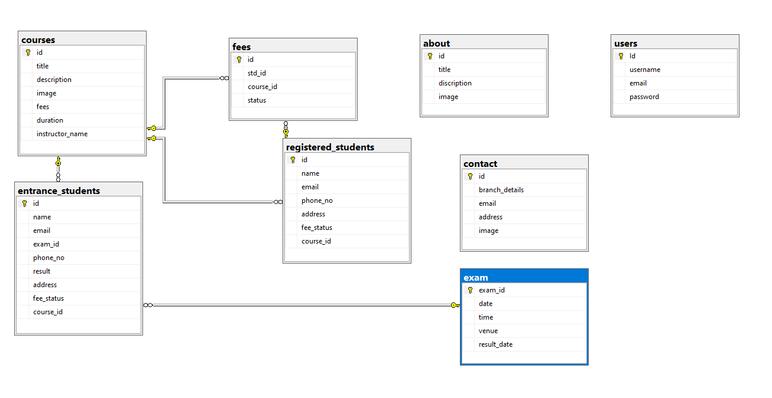

**ADMIN SCREENSHORTS**

**LOGIN**

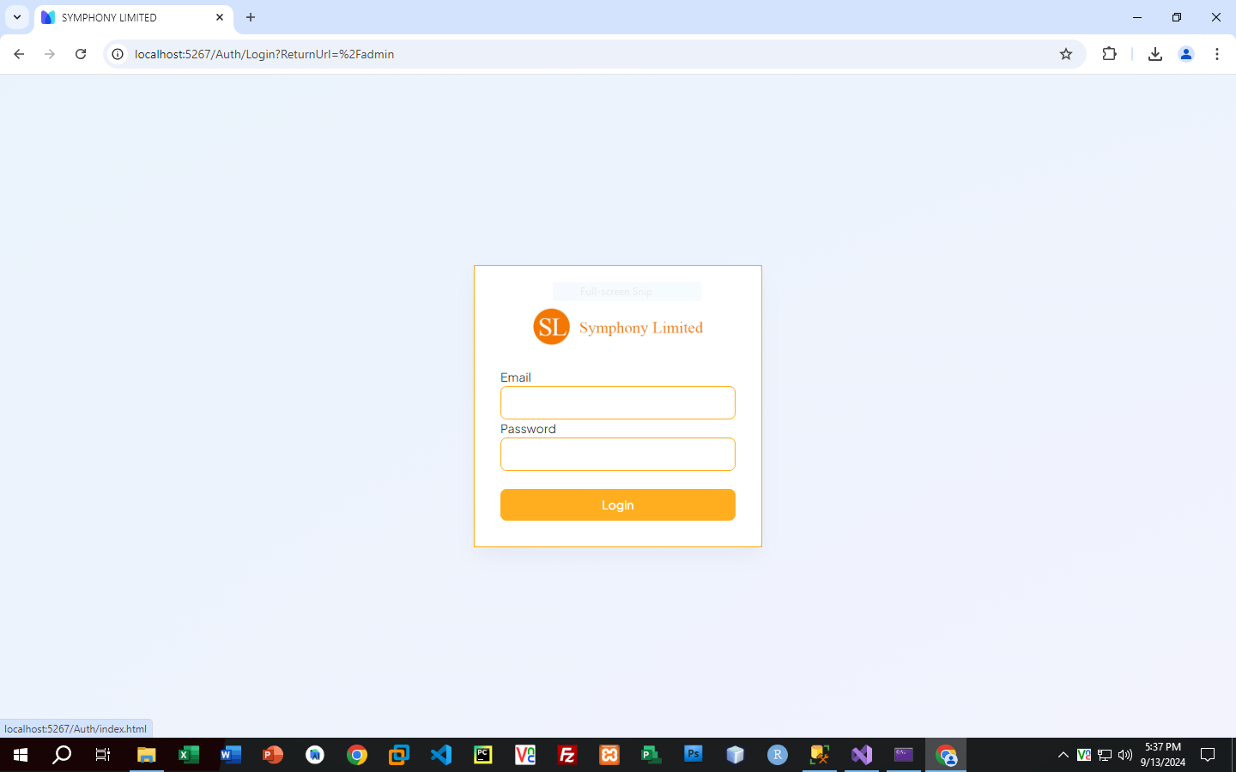

**HOME**

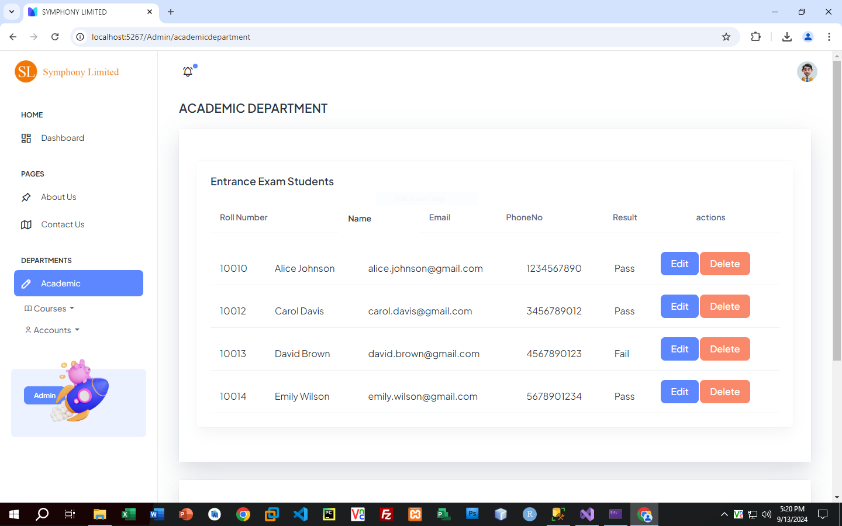

**REGISTER STUDENTS**

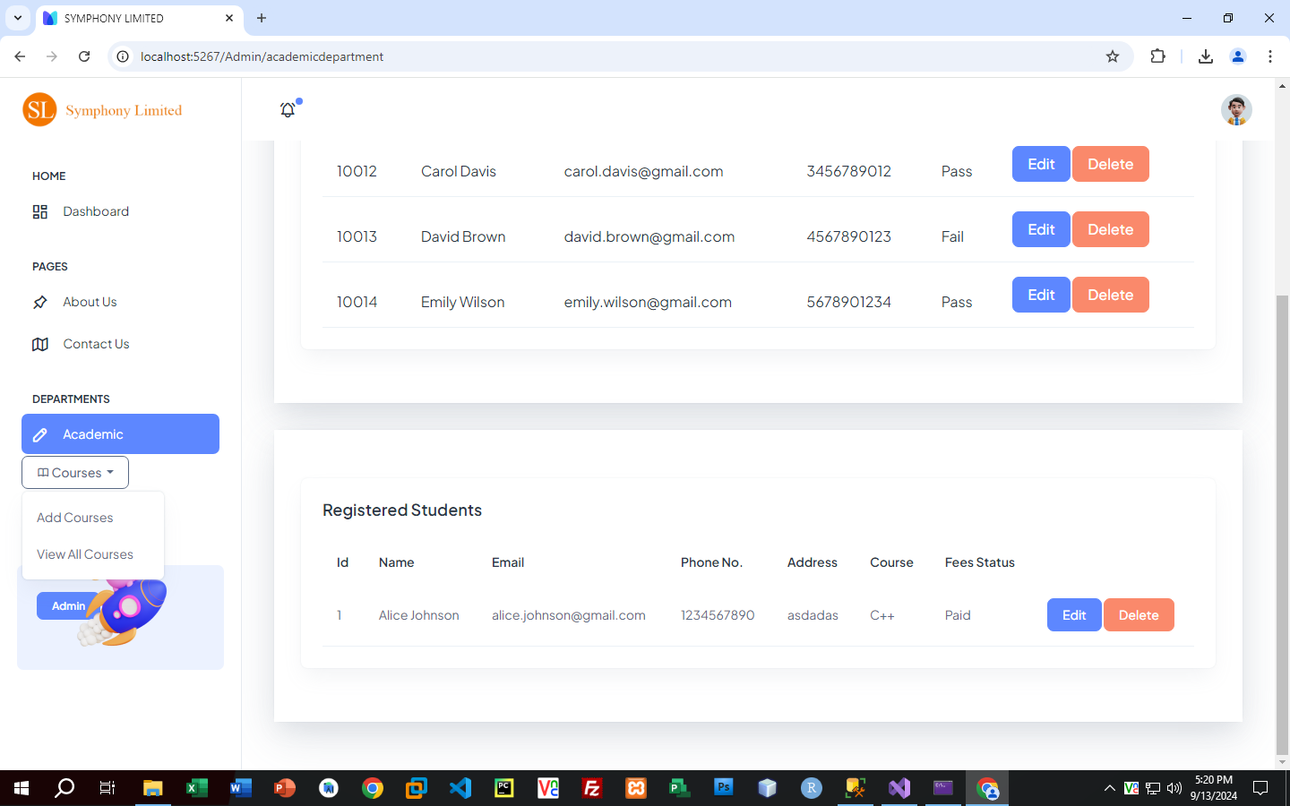

**ADD COURSE FORM**

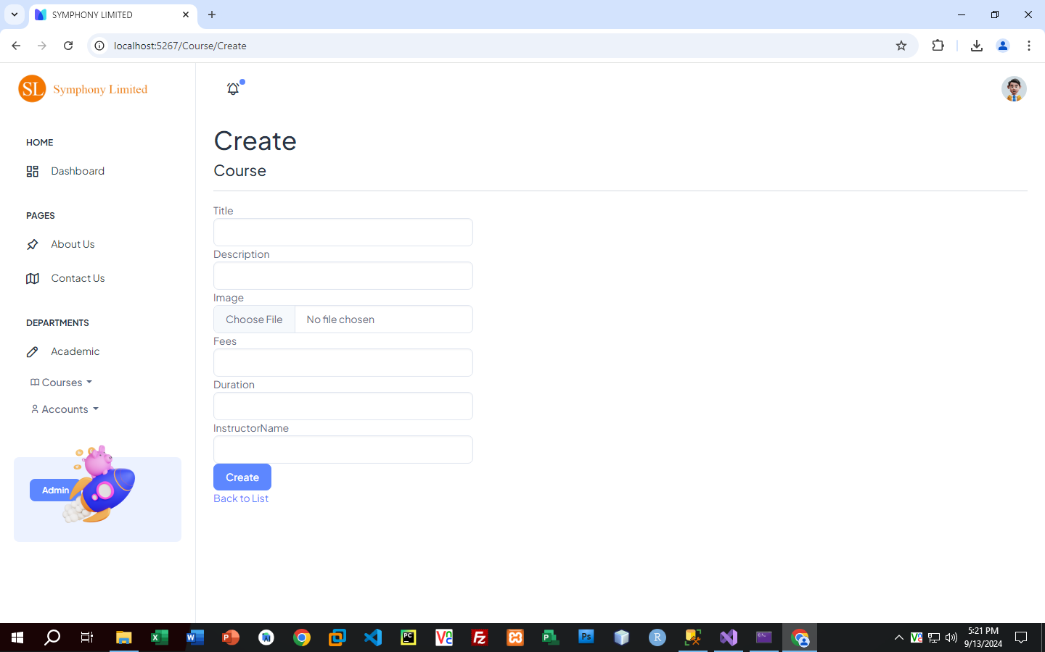

**ADD RECORD FORM**

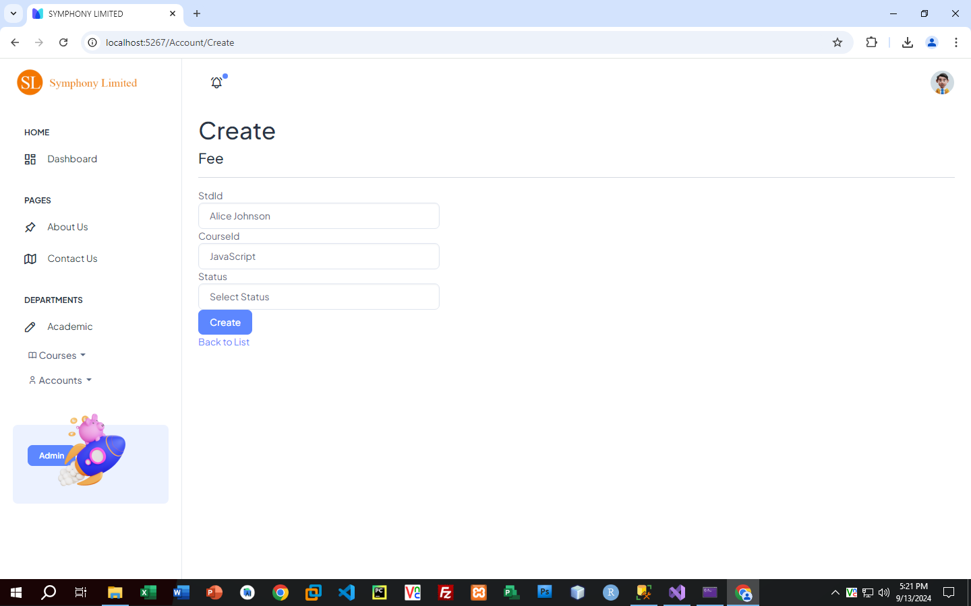

**EDIT COURSE FORM**

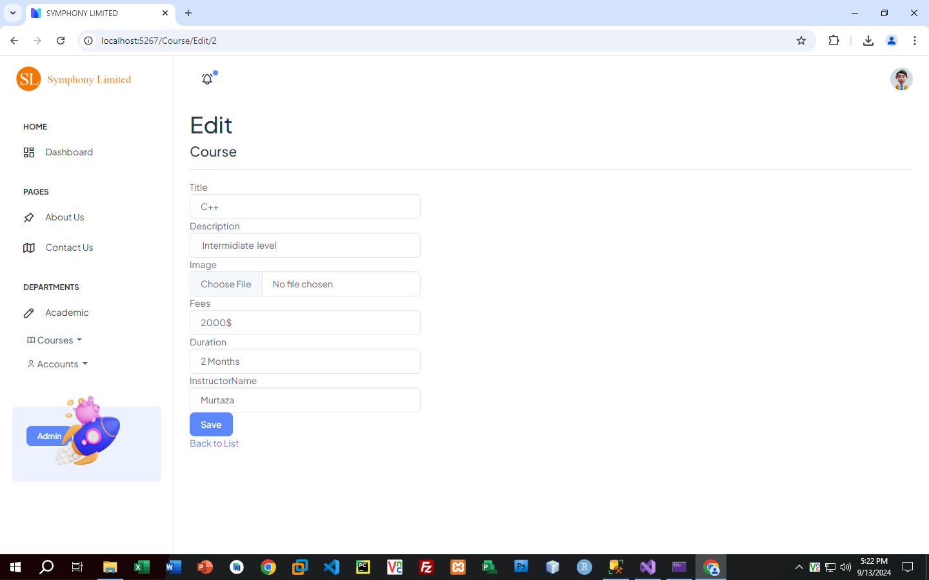

**DELETE COURSE FORM**

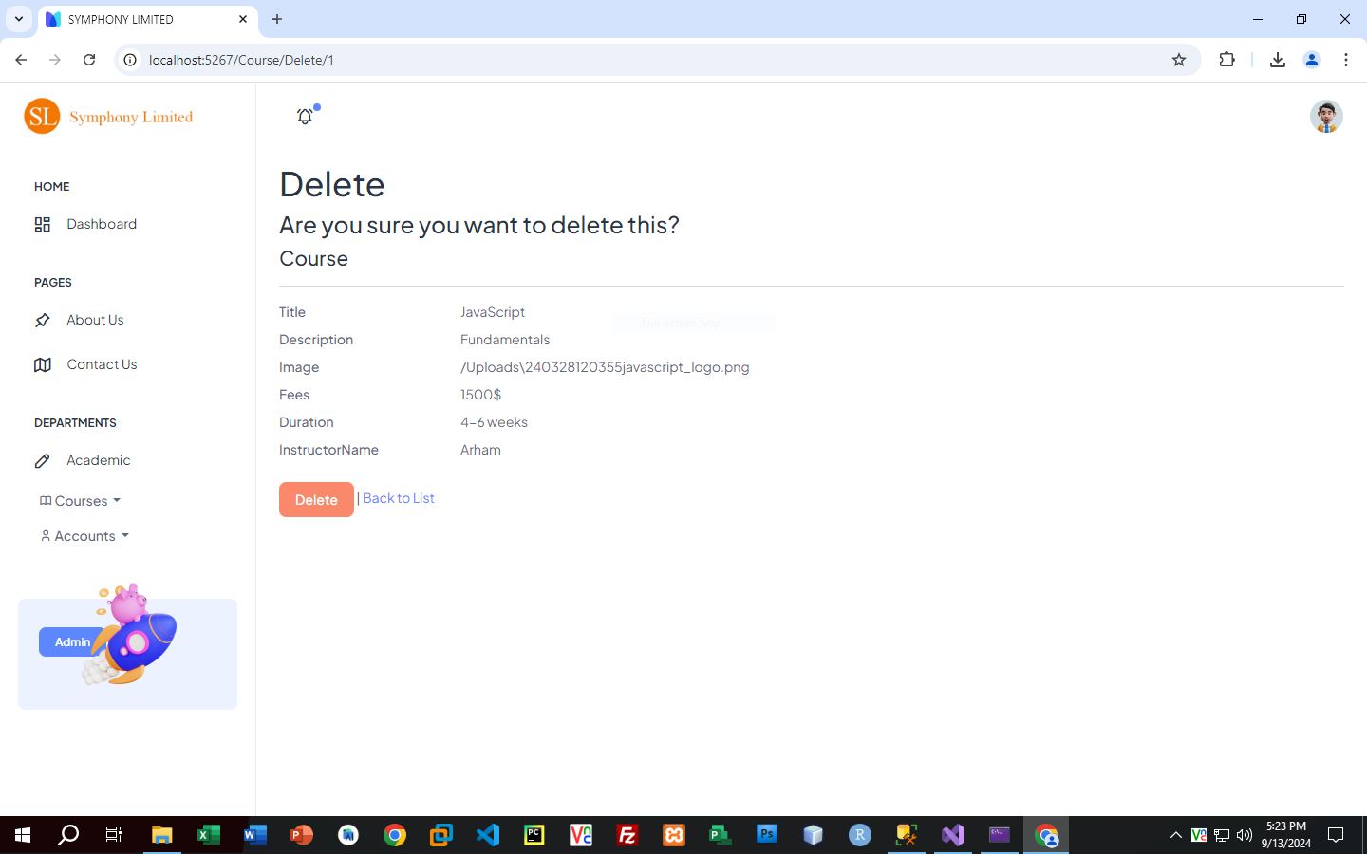

**VIEW RECORDS**

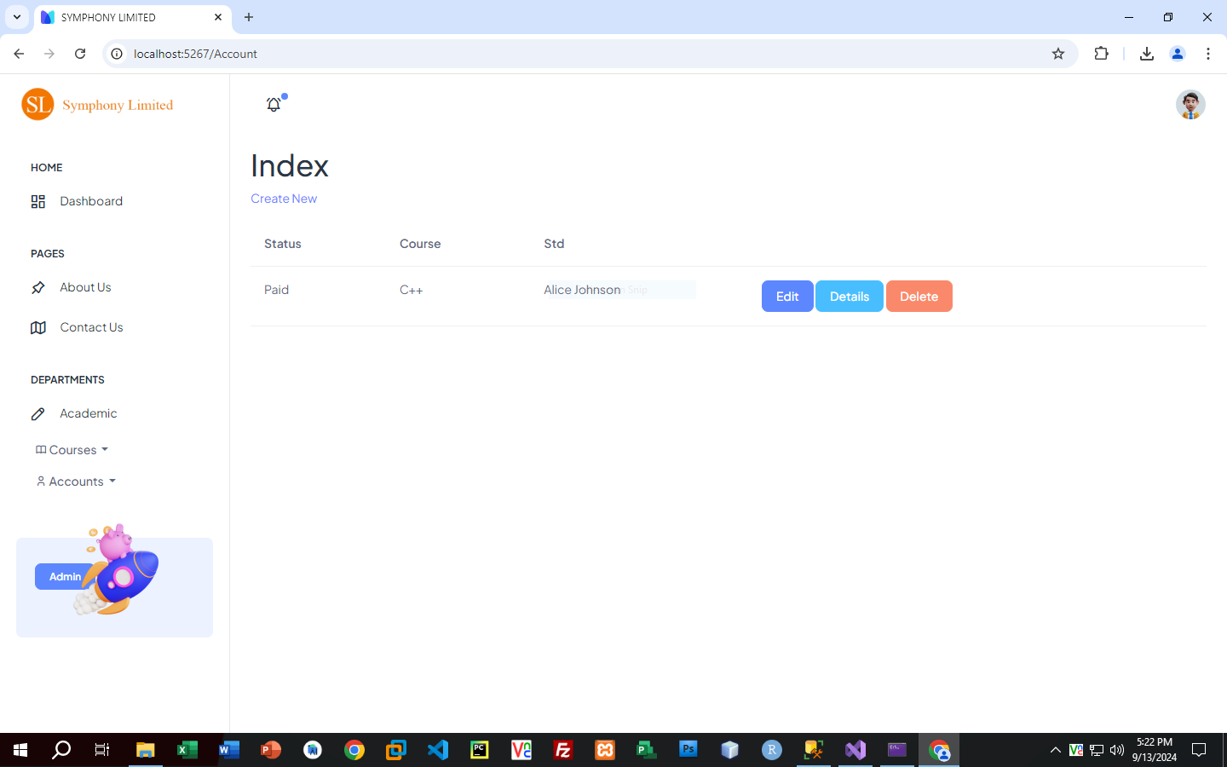

**VIEW COURSE**

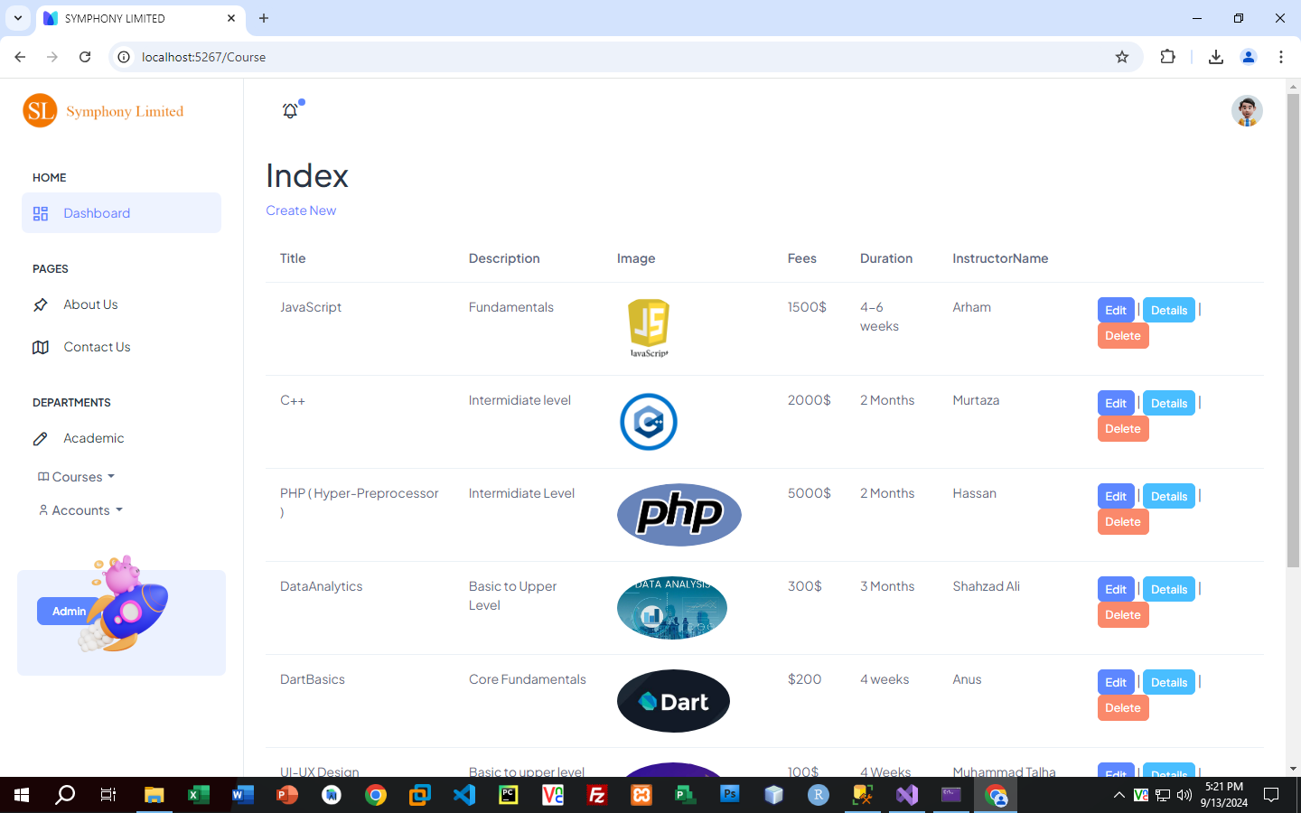

**WEBSITE SCREENSHORTS**

**HOME**



**ABOUT**

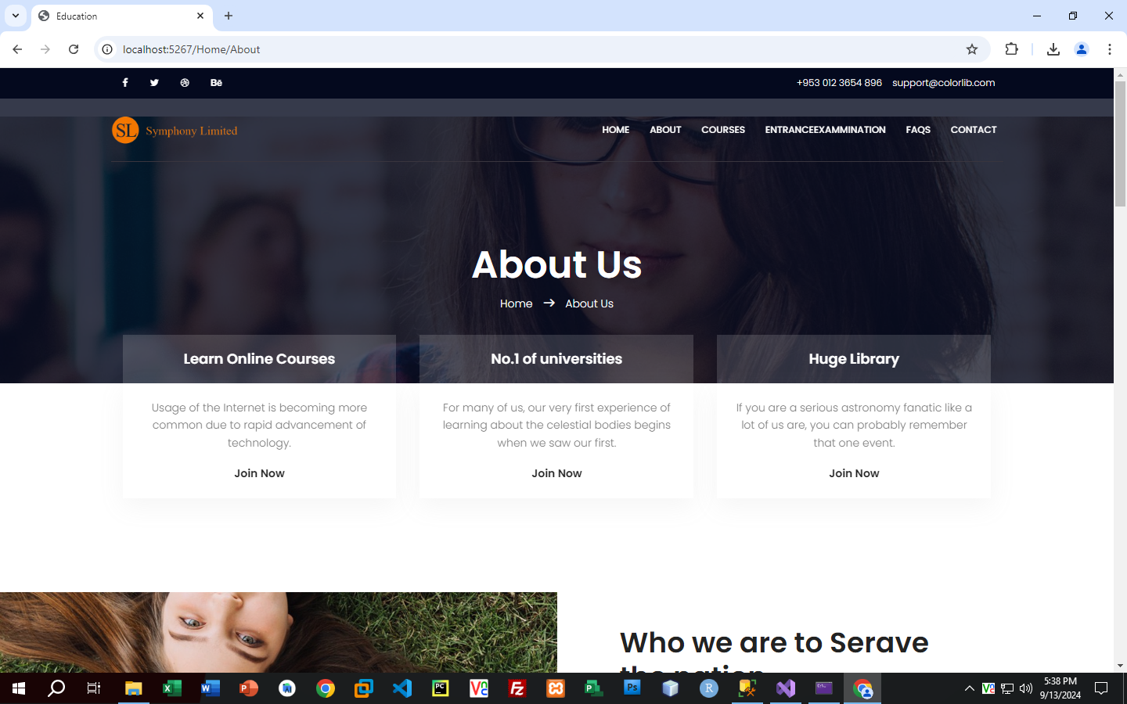

**COURSE**



**COURSE-DETAIL**

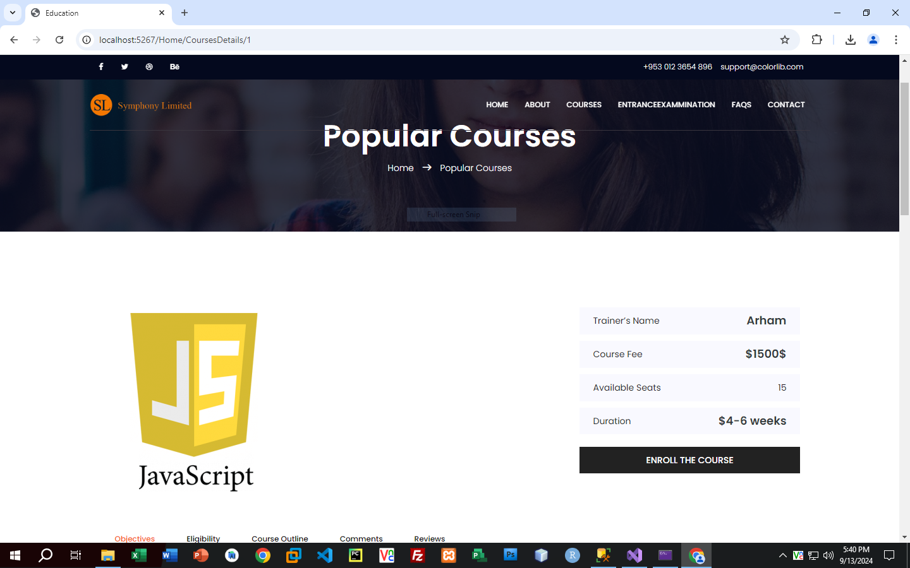

**ENTER EXAM**

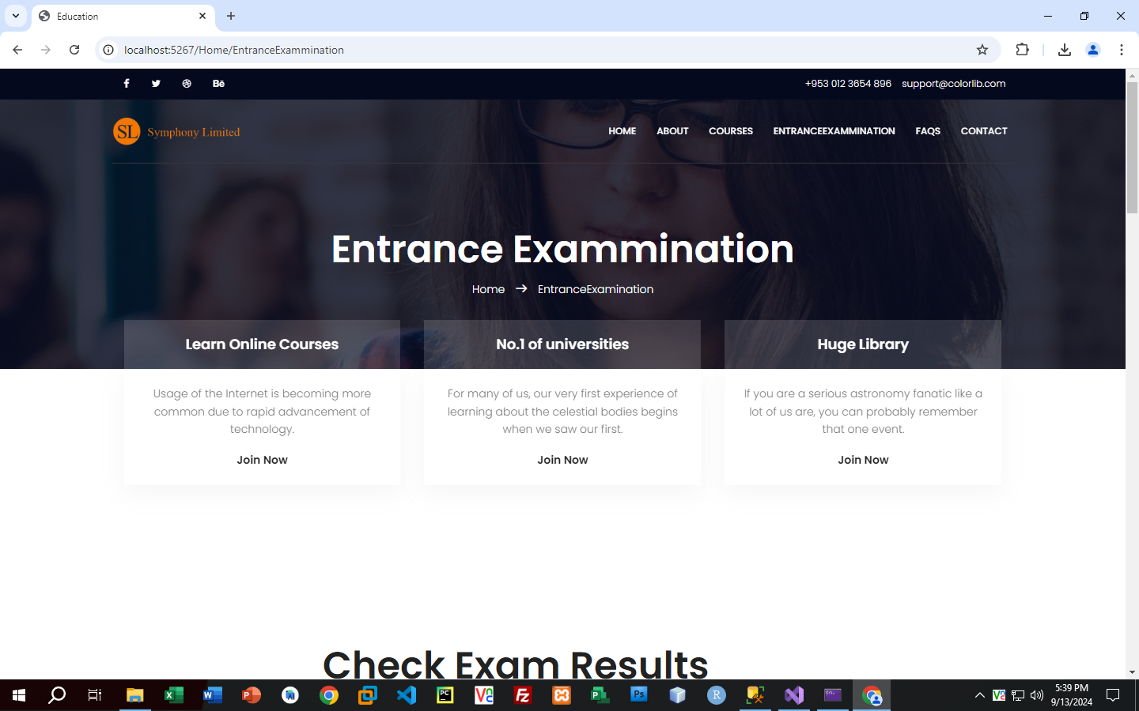

**FAQ**

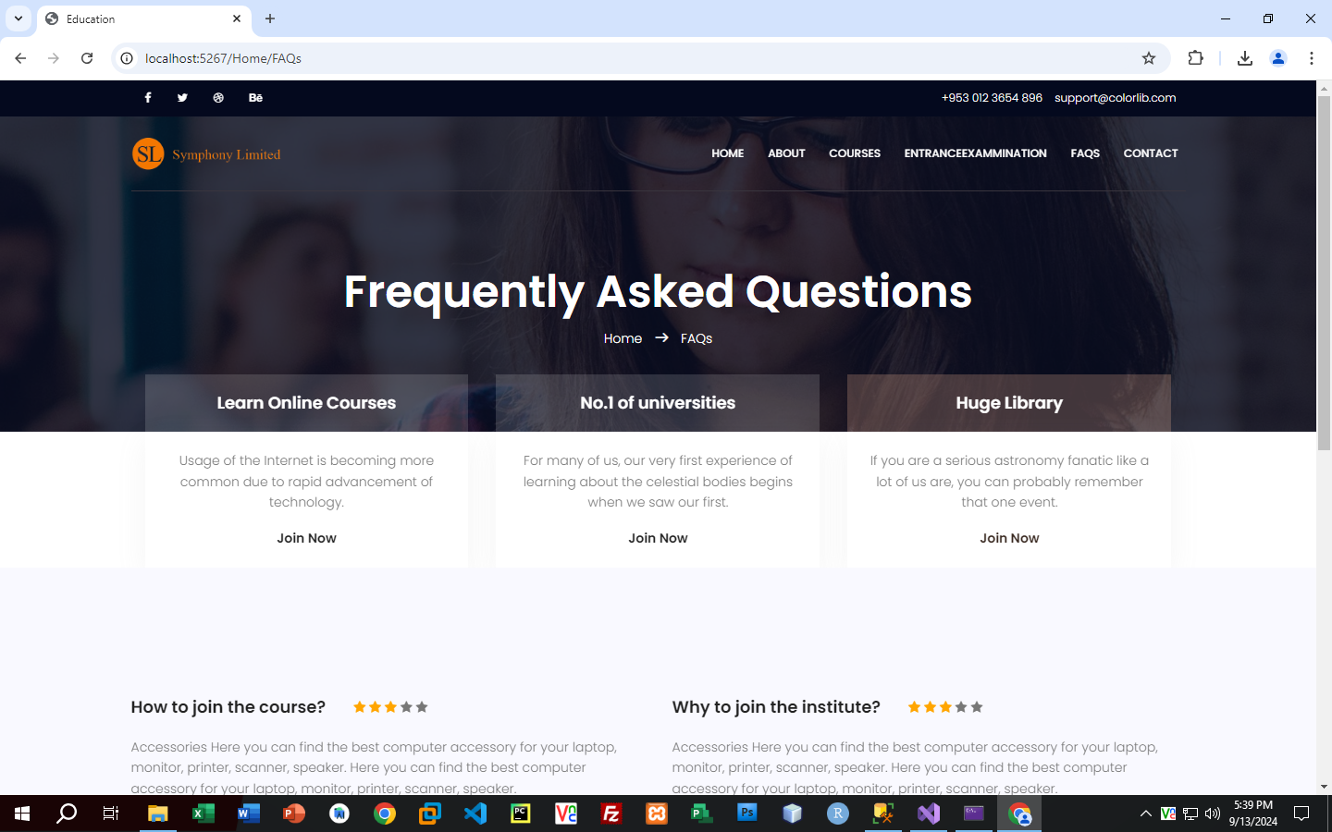

**CONTACT**

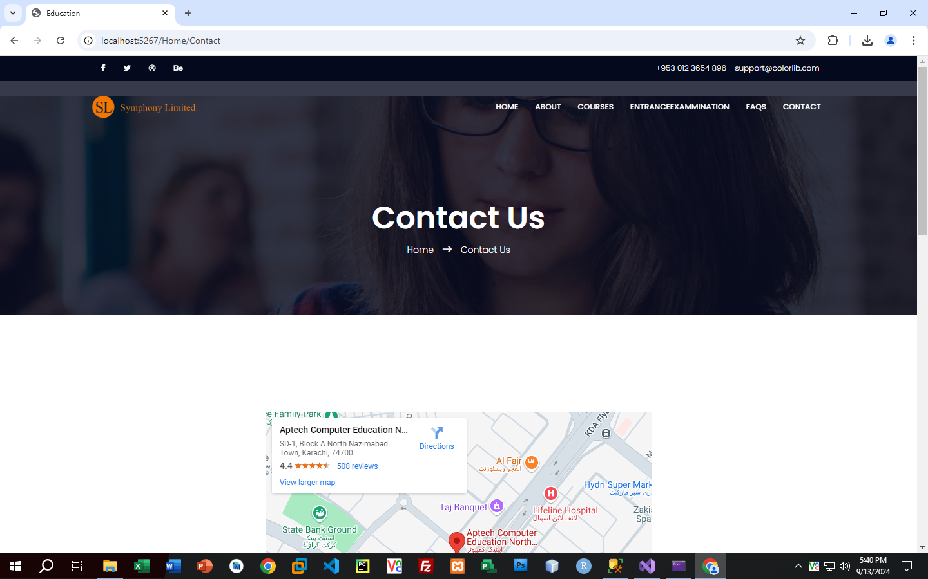

**TASKSHEET**

|  |  |  |  |
| --- | --- | --- | --- |
| ***sn*** | ***Task*** | ***Team-member*** | ***status*** |
| *1* | *Analysis* | *Talha,Murtaza,Hassan* | *done* |
| *2* | *design* | *Anas,Arham* | *done* |
| *3* | *Development* | *Murtaza,talha,hassan* | *done* |
| *4* | *Documentation* | *Arham* | *done* |
| *5* | *finalization* | *Talha,Arham* | *done* |

**CHECK LIST**

|  |  |  |  |
| --- | --- | --- | --- |
| *S.no* | *List of items* | *Remarks* | *Comments* |
| ***1.*** | *Do All Pages Linked*  *together* | ***Yes*** | *✓* |
| ***2.*** | *Authorization* | ***Yes*** | *✓* |
| ***3.*** | *Crud Operations* | ***Yes*** | *✓* |
| ***4.*** | *Database Connection* | ***Yes*** | *✓* |
| ***6.*** | *Feedback Form*  *Included* | ***Yes*** | *✓* |
| ***7.*** | *Project Zip File* | ***Yes*** | *✓* |